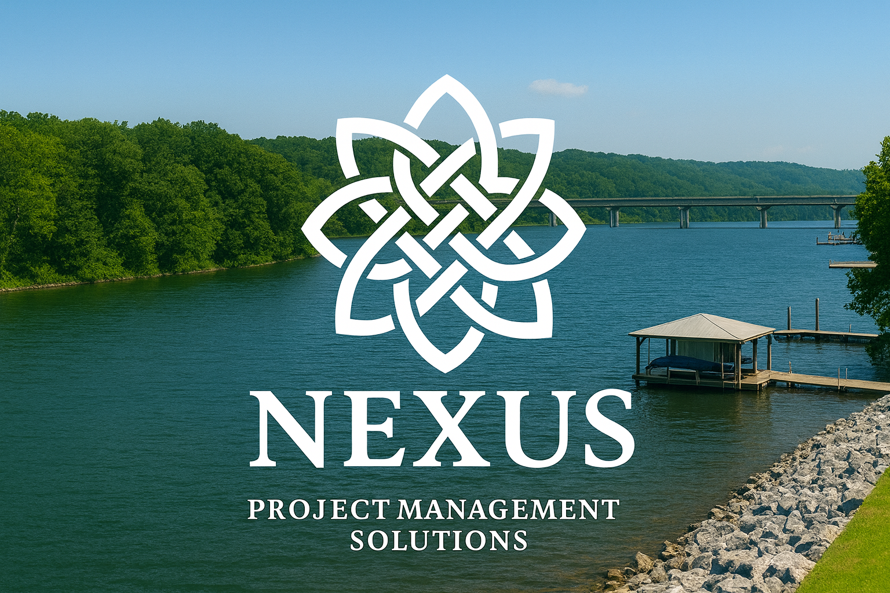
______________________________________________________________

NEXUS PM SOLUTIONS, LLC
EXPERT GUIDANCE FOR WATERFRONT TVA-REGULATED PROJECTS

Who We Are  Nexus PM Solutions was founded in 2025 to help clients navigate the complexities of the Tennessee Valley Authority (TVA) and related regulatory processes. With more than 45 years of combined TVA Natural Resources and land-management experience, our team understands exactly how to move projects forward efficiently and correctly.  Why Clients Choose Us  • Deep institutional TVA experience – Over 20 years of experience  • Strong relationships with TVA staff & partner agencies  • Real-world expertise in shoreline & environmental projects  • Full-service support from planning through construction  • A commitment to getting it right the first time | Our Core Services  Section 26a Permitting  Complete management of TVA approvals for docks, marinas, shoreline stabilization, floating cabins, boat ramps, municipal, commercial, and industrial waterfront facilities, utilities, and water-dependent structures.  TVA Land Use Agreements  Support for licenses, special-use permits, easements, utilities, deed modifications, and other real-property actions requiring TVA approval.  Project Planning & Due Diligence  Site feasibility review, early TVA consultation, environmental considerations, and project risk identification.  Conflict Resolution & Negotiation  Have a problem you can’t seem to solve. We find creative solutions to complex issues, helping clients achieve their goals within the bounds of established regulations.

Who We Support
Dock builders • Developers • Engineers • Surveyors • Municipalities • Counties • Marinas • Campgrounds •
Commercial operators • Industrial clients • Utility providers • Private landowners

Contact Us
Ben Bean, Founder and COO
256-558-5122 — nexuspmsolutions@gmail.com

